Assignment 1
Title: Handle Arithmetic Exception
Problem Statement: Write a Java program that accepts two integers and performs division. Handle the scenario where the denominator is zero.
Expected Outcome: Program should not crash and should display "Division by zero is not allowed".
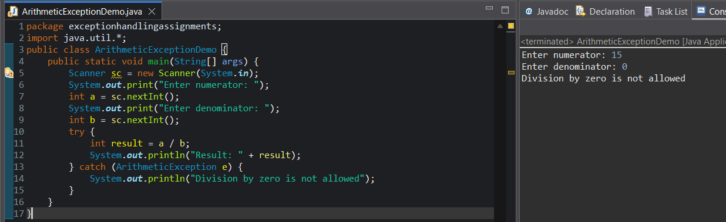
Assignment 2
Title: Handle Array Index Exception
Problem Statement: Create an array of size 5 and try to access an invalid index.
Expected Outcome: Program should print "Invalid array index accessed".
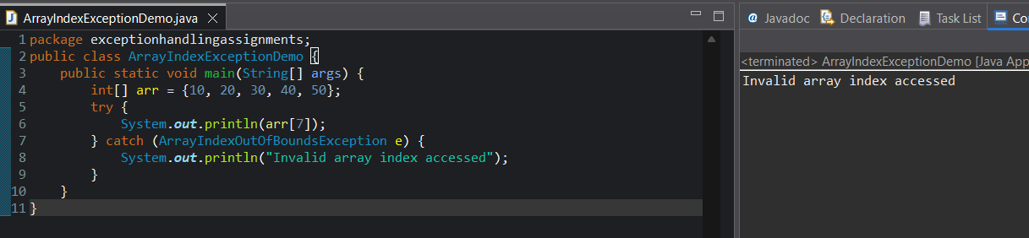
Assignment 3
Title: Handle Null Pointer Exception
Problem Statement: Create a string variable with null value and attempt to call a method on it.
Expected Outcome: Program should handle the exception gracefully.
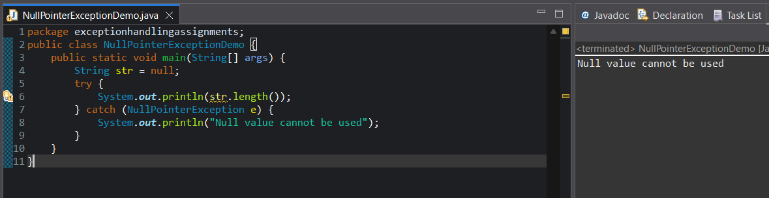

Assignment 4
Title: Multiple Catch Blocks
Problem Statement:Write a program that can throw both ArithmeticException and ArrayIndexOutOfBoundsException.
Expected Outcome: Correct exception should be caught and message displayed.
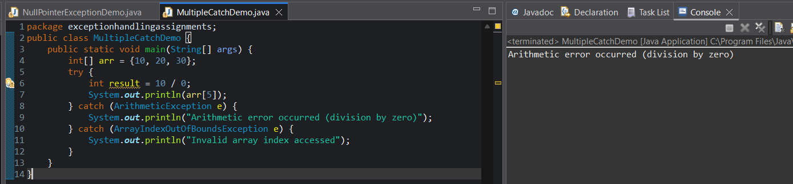
Assignment 5
Title: Exception Handling with finally Block
Problem Statement: Write a program that opens a file and ensures the file resource is closed using finally.
Expected Outcome: finally block should always execute.
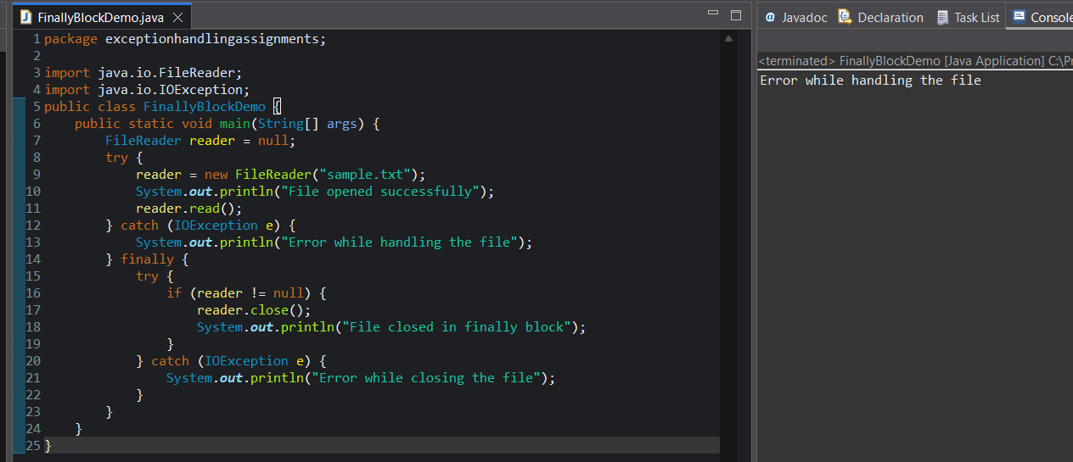

Assignment 6
Title: Nested Try-Catch
Problem Statement: Demonstrate nested try-catch blocks for handling different exceptions at different levels.
Expected Outcome: Proper exception handling at each level.
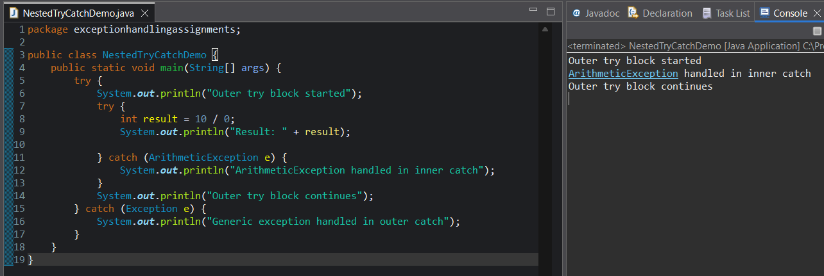
Assignment 7
Title: User Input Validation Using Exception
Problem Statement: Accept user input for age and validate that age must be greater than 18.
Expected Outcome: Program should display "Age not eligible".
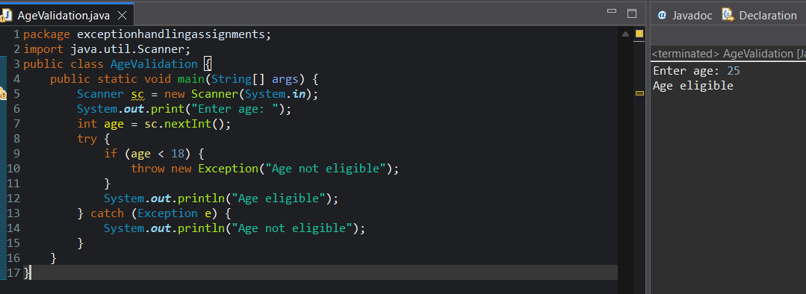

Assignment 8
Title: Custom Exception Creation
Problem Statement: Create a custom exception called InvalidBalanceException for a bank application.
Expected Outcome: Custom exception message should be displayed.
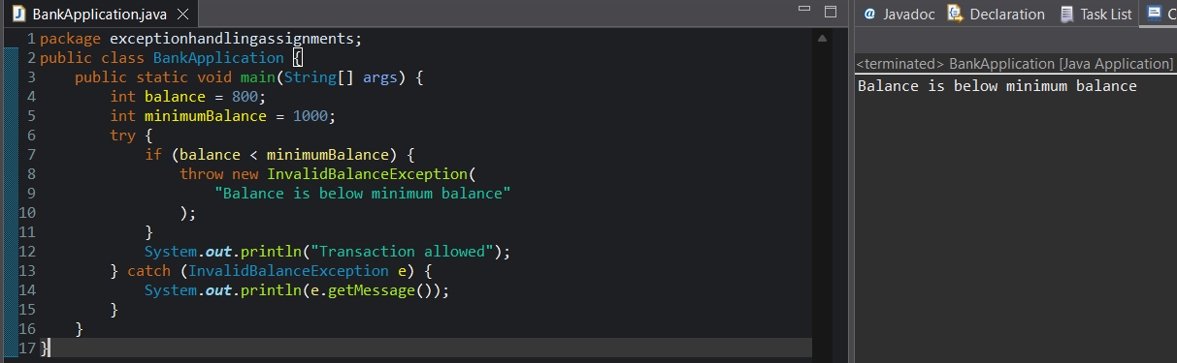
Assignment 9
Title: Exception Propagation
Problem Statement: Write a program where an exception occurs in one method and is propagated to the calling method.
Expected Outcome: Exception should propagate correctly and be handled.
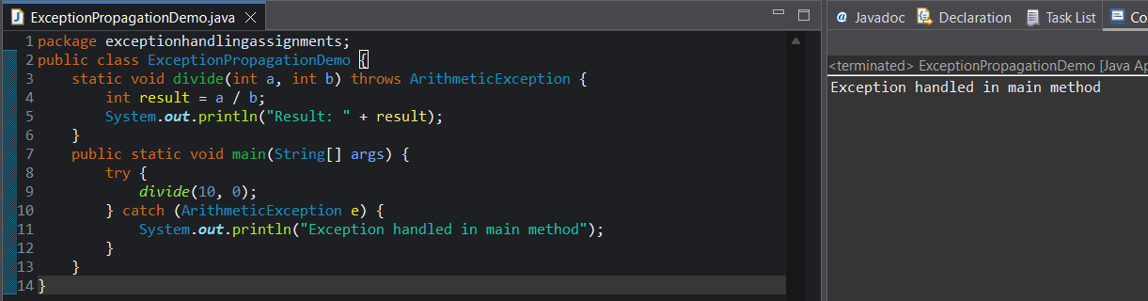

Assignment 10
Title: Re-Throwing an Exception
Problem Statement: Catch an exception, log a message, and rethrow it to the calling method.
Expected Outcome: Both log and exception handling should occur.
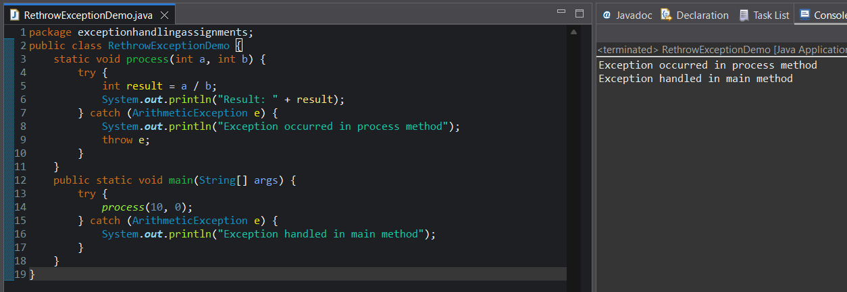
Assignment 11
Title: Exception Handling in Method Overriding
Problem Statement: Demonstrate rules of exception handling in method overriding using parent and child classes.
Expected Outcome: Program should compile and run successfully.
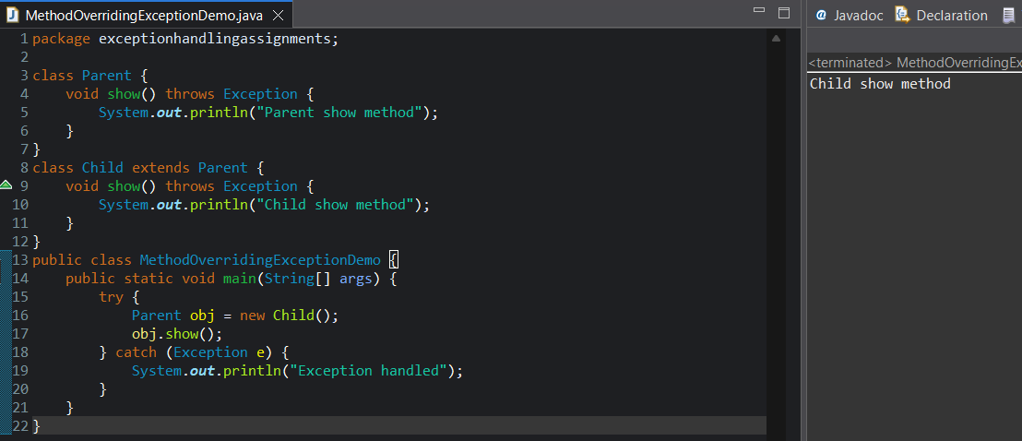

Assignment 12
Title: Exception Handling with Custom Validation Layer
Problem Statement: Design a service method that validates input and throws different custom exceptions based on validation failure.
Expected Outcome: Different error messages based on failure type.
